Step 1: Turn on Stratagene PCR machine.
Step 2: Open Mx3000P program.
Step 3: Select the experiment type. Explanation of each type of experiment can be located in the Mx3000p Manual. We selected SYBR Green for our experiment. Click OK.
Step 4: You will now enter a page with two main tabs (Plate Setup and Thermal Profile Setup). In the plate setup menu you will name the contents of each well or tube. This will allow the program to keep track of each sample.
- To name a cell: Double click on the cell. The program will prompt you for the name of the cell and any additional comments.
- On the right hand side you will be allowed to select the type of well. There are several different types of wells. We will only use three types: NTC, no template control, unknown, for data, and Standard for comparison purposes. In our experiments the standards are wildtype, while the mutant strains are unknown.
- After selecting the type of well it is important that you specify how you would like to collect fluorescence data. If you are using SYBR green click the SYBR green box, if not click the corresponding location.
- For entering standard values you will need to choose a standard quantity for the well and the standard units. It is easiest, when working with DNA to use nanograms.
After naming and layout each cells, you will need to determine the PCR conditions with which you would like to run the PCR. You should have already tested each set of primers, and will use the same reaction conditions.
Step 5: Click on the Thermal Profile Setup tab
Step 6: You will notice that there are 3 distinct Segments. Segment 1 is responsible for denaturing the DNA and should not be changed. Segment 2 should contain three separate platueas and should be altered to meet your specified PCR conditions. This can be done by click and dragging each plateau to the desired temperature. 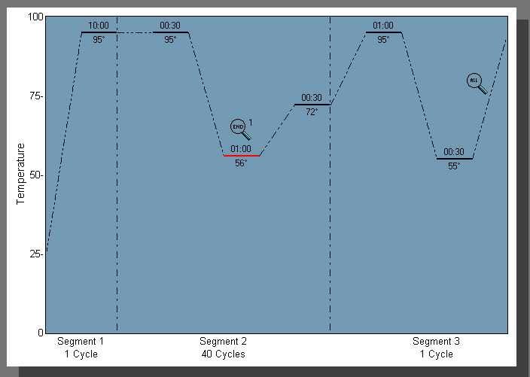
The third and final segment needs to be altered as well to correspond to the melting temperature of your primers. This segment will allow for a disassociation curve to be produced. This curve will provide information about primer dimers.
Step 7: After the termal profile is setup properly, you are now ready to run qPCR. For any other information one should consult the Mx3000p Manual.

